**Assignment-1**

1. WACP to find the sum of Fibonacci series.

**Code-**

#include<stdio.h>

int main()

{

int a=0, b=1, range, c, sum=0;

clrscr();

printf("Enter the range of Fibonacci series: ");

scanf("%d",&range);

printf("The fibonacci series is: \t");

while( a <= range )

{

printf("%d\t",a);

sum += a;

c = a + b;

a = b;

b = c;

}

printf("\nTheir sum is = %d", sum);

return 0;

}

**Output-**

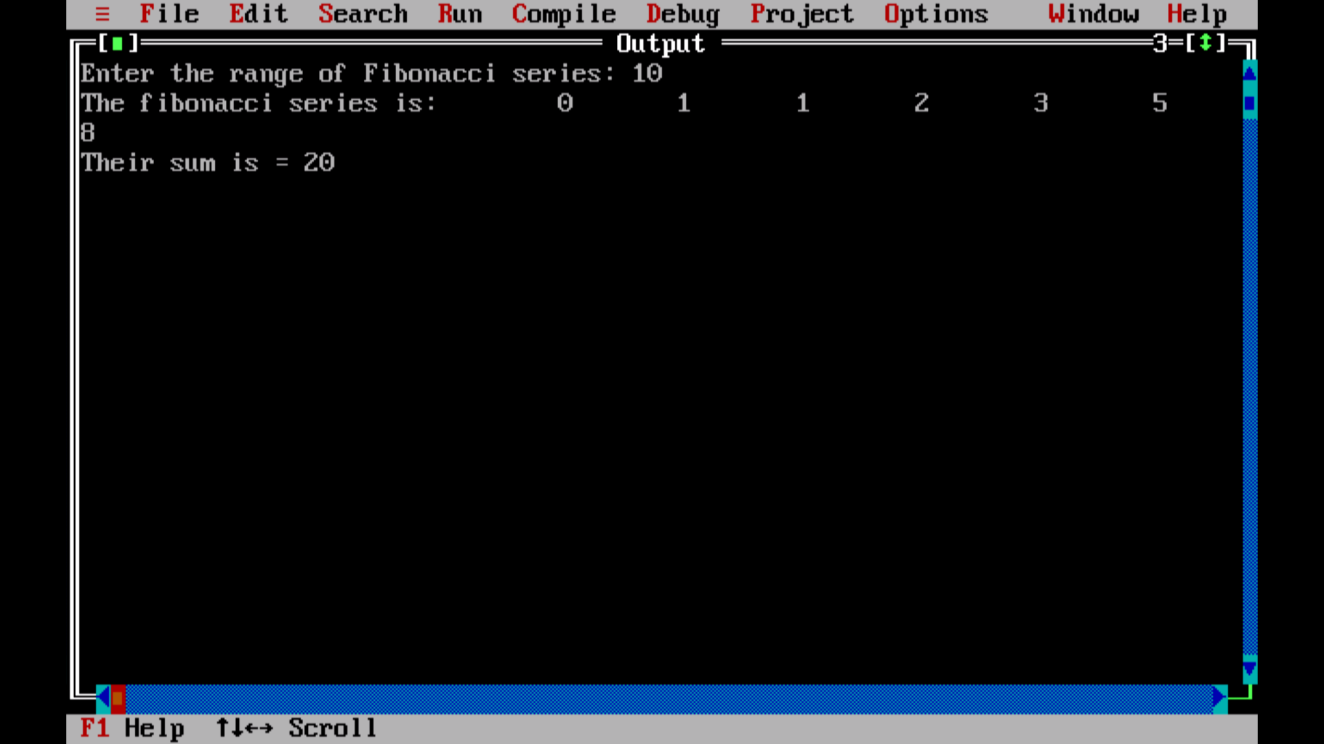

1. WACP to find the sum of even numbers of n numbers.

**Code-**

#include<stdio.h>

int main()

{

int i, number, sum = 0;

clrsccr();

printf("\nEnter the Maximum Limit Value : ");

scanf("%d", &number);

printf("\n Even Numbers between 0 and %d are : ", number);

for(i = 1; i <= number; i++)

{

if ( i%2 == 0 )

{

printf("%d ", i);

sum = sum + i;

}

}

printf("\n The Sum of All Even Numbers upto %d = %d", number, sum);

return 0;

}

**Output-**

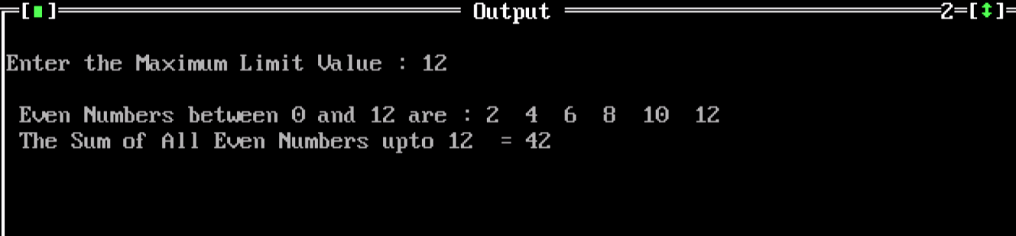

1. WACP to find sum of odd numbers of n numbers.

**Code-**

#include<stdio.h>

int main()

{

int i, number, sum = 0;

clrscr();

printf("\n Enter the Maximum Limit Value : ");

scanf("%d", &number);

printf("\n Odd Numbers between 0 and %d are : ", number);

for(i = 1; i <= number; i++)

{

if ( i%2 != 0 )

{

printf("%d ", i);

sum = sum + i;

}

}

printf("\n \n The Sum of Odd Numbers from 1 to %d = %d", number, sum);

return 0;

}

**Output-**

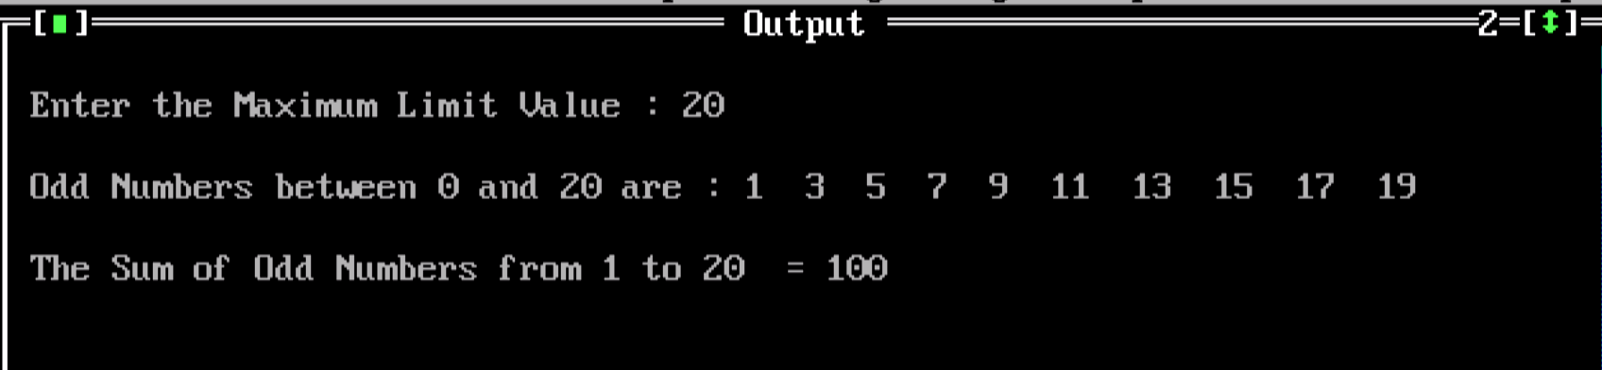

4.WACP to print

a. Hello World

b. Hello world

c. hello world

d. HELLO WORLD

**Code-**

#include <stdio.h>

#define MAX 100

int main()

{

char str[MAX]={0};

int i;

clrsrc();

printf("Enter a string: ");

scanf("%[^\n]s",str);

strupr(str);

printf("%s\n",str);

for(i=0; str[i]!='\0'; i++)

{

if(i==0)

{

if((str[i]>='a' && str[i]<='z'))

str[i]=str[i]-32;

continue;

}

if(str[i]==' ')//check space

{

++i;

if(str[i]>='a' && str[i]<='z')

{

str[i]=str[i]-32;

continue;

}

}

else

{

if(str[i]>='A' && str[i]<='Z')

str[i]=str[i]+32;

}

}

printf(" %s\n",str);

strlwr(str);

for(i=0; str[i]!='\0'; i++)

{

if(i==0)

{

if((str[i]>='a' && str[i]<='z'))

str[i]=str[i]-32;

}

}

printf(" %s\n",str);

}

**Output-**

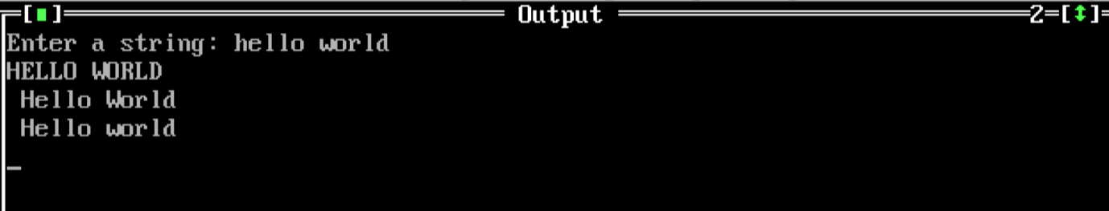

1. WACP to implement string methods.

**Code-**

#include <stdio.h>

#include <string.h>

int main()

{

char s1[10] = "Hello";

char s2[10] = "World";

strcat(s1,s2);

printf("Output string after concatenation: %s", s1);

return 0;

}

**Output-**

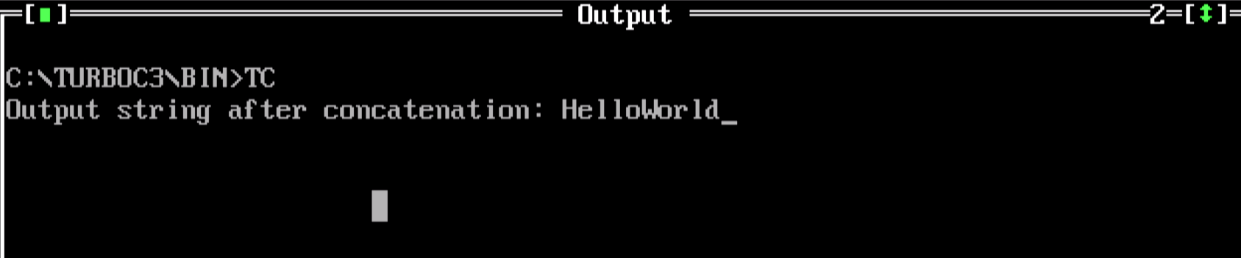

**Assignment-2**

1. Range and xrange methods

Examples for range()

1. **Code-**

# Print first 5 numbers using range function

for i in range(5):

print(i, end=', ')

**Output-**

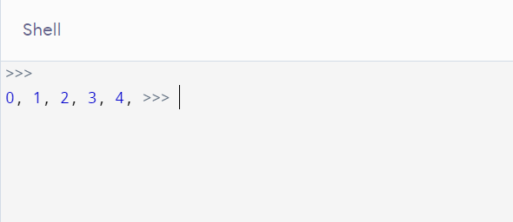

1. **Code-**

# Print integers within given start and stop number using range()

for i in range(5, 10):

print(i, end=', ')

**Output-**

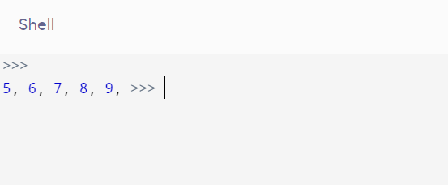

1. **Code-**

# using start, stop, and step arguments in range()

print("Printing All even numbers between 2 and 10 using range()")

for i in range(2, 10, 2):

print(i, end=', ')

**Output-**

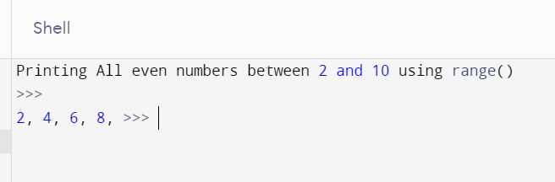

Examples for xrange()

1. **Code-**

print("Specify end position only\n")

end=5

print("end position:",end)

x = xrange(end)#create a sequence of numbers from 0 to 4

print(x)

for n in x:#print the elements using a for loop

print(n)

**Output-**

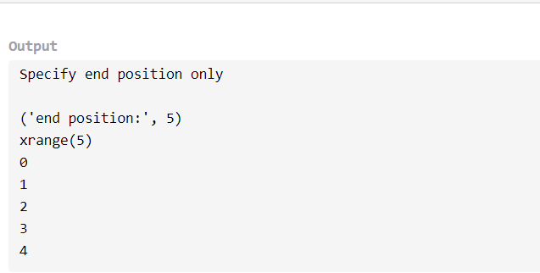

1. **Code**

print("\n\nSpecify both start and end position")

start=2

end=5

print("start position:",start)

print("end position:",end)

y = xrange(start,end)#create a sequence of numbers from 2 to 5

print(y)

for n1 in y:#print the elements using a for loop

print(n1)

**Output-**

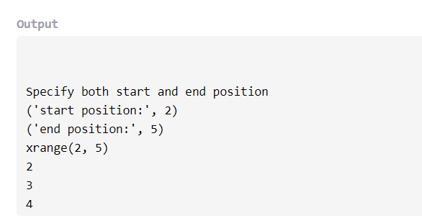

1. **Code-**

print("\n\nSpecify both start,end position and step")

start=2

end=5

step=2

print("start position:",start)

print("end position:",end)

print("step:",step)

z = xrange(3,10,2)#create a sequence of numbers from 3 to 10 with increment of 2

print(z)

for n2 in z:#print the elements using a for loop

print(n2)

**Output-**

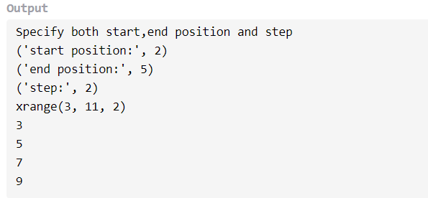

2. To print the largest of 2 numbers.

**Code-**

num1 = int(input("Enter the first number: "))

num2 = int(input("Enter the second number: "))

print(max(num1, num2), "is greater")

**Output-**

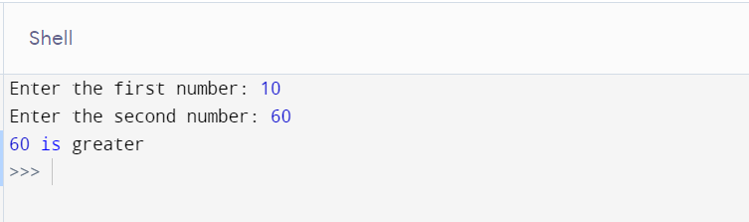

1. To print the smallest of 3 numbers.

**Code-**

num1=int(input("Enter the first number: "))

num2=int(input("Enter the second number: "))

num3=int(input("Enter the third number: "))

if(num1<=num2 and num1<=num3):

print(num1," is the smallest")

elif(num2<=num1 and num2<=num3):

print(num2," is the smallest")

else:

print(num3," is the smallest")

**Output-**

